Servo Sweep Quiz Name______________________________

Given the ROBOTC code below, write the pseudocode that will describe what the program is executing. (10 points possible)

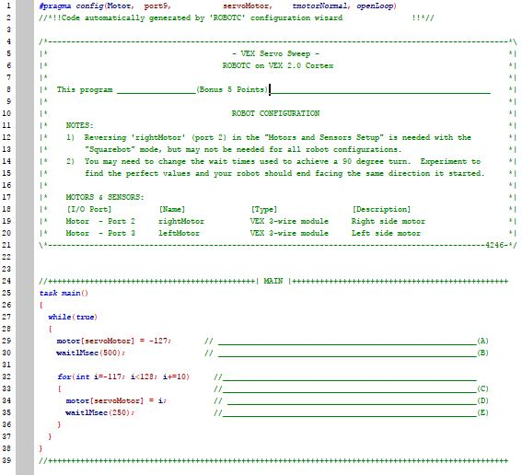

1. Set servo all the way back
2. Do it in 1 sec
3. Loop until 1 is 128 then add 10 after each loop when done rst back to -127
4. Set servo to i
5. Do it in 25/100th of a second

What happens during the execution of this program? (5 bonus points, complete sentences) move servo to potion -127 then add 10 to it on a loop